Staff Mental Health and Wellbeing Policy Template

To successfully embed a health promotion message within your school, it is vital to include it at policy level. This enables your school to develop a clear plan of what you want to do and why. The policy should be guided by your school’s core values. This helps to ensure consistency and accountability and helps guide decision makers.

To become a Mentally Healthy School and promote mental health and wellbeing throughout school staff it must be reflected in your school’s Health Policy. This can be done in two ways:

- create a new Mental Health Policy with the support of the Mentally Healthy WA team; or
- incorporate new mental health specific objectives into a pre-existing Health Policy that encompass mental health and wellbeing.

When writing a policy, it is important to consider what policies already exist and what your school needs. The Health and Wellbeing committee (or a dedicated group of staff at your school that addresses this area) can work together to develop a simple policy encompassing mental health and Act Belong Commit.

This policy should be customised to suit your school’s needs, circulated to all staff and other relevant bodies (School Board, P&C, Staff.) for feedback and reviewed annually. The policy will then function as a guide for the development of your Mentally Healthy Action Plan – the action plan will be practical strategies to achieve your policy’s objectives.

The following resource is a template policy to add mental health and wellbeing as an overall strategy for staff and to further assist the implementation of Act Belong Commit. Use the Staff Mental Health Policy Template or you can include some of the example objectives in your already existing Health Policy. If you require further assistance with this process, please do not hesitate to call the Schools Program Coordinator on (08) 9266 1873.

Staff Mental Health and Wellbeing Policy Template

School Name:
Created By:
Date Created:
Date Reviewed:
Next Review:

Related Department of Education Policies [Remove if unnecessary for your school]

This policy supports the following Department of Education Policies:
Staff health and wellbeing strategy 2023-2027
Equal Opportunity Discrimination and Harassment Policy
School Improvement and Accountability in Public Schools Policy
Bullying in the Workplace Policy

Related [School Name] Policies

Please provide list / links to related internal school policies.
Provide details for School/Department EAP service(s).

Rationale

This is a sample rationale, consider the context of your school and tailor it for your school’s particular needs and priority areas.

This policy will outline how we intend to embed Act Belong Commit® into our whole school staff and culture to promote the mental health of our whole school community.

We aim to provide a safe, stimulating, and fun place to learn, work and play.

Promoting good mental health and encouraging staff to take proactive steps to protect their mental health and wellbeing are vital to mental, emotional, and physical health, and overall happiness. Staff who are mentally healthy and active, have good positive relationships with students and colleagues, and add meaning and purpose to their life. They are also more likely to have higher self-esteem, resiliency and confidence and achieve better academically, socially, and emotionally.

Enhancing wellbeing requires the promotion of positive mental health and wellbeing. Given the stress, burnout, and attrition of school staff, interventions to enhance protective factors are vital. Promoting positive mental health within all school staff is vital. We aim to provide inclusive mental health promotion strategies to promote mental health and wellbeing and to equip staff with help seeking skills and be able to support themselves, colleagues, and students including referring them to relevant services when appropriate.

- Act – Stay active mentally, physically, socially, and spiritually.
- Belong – Maintain connections with colleagues and the school community.
- Commit – Engage in meaningful work and activities that provide purpose.
- Embed Act Belong Commit® principles into staff wellbeing initiatives.

Purpose
The purpose of this policy is to promote and support the mental health and wellbeing of all staff members. Our school recognises that staff wellbeing is essential for creating a positive work environment, enhancing job satisfaction, and ensuring the delivery of high-quality education.

Scope

This policy applies to all staff members employed at the school, including teaching, administrative, and support staff.

Policy Statement
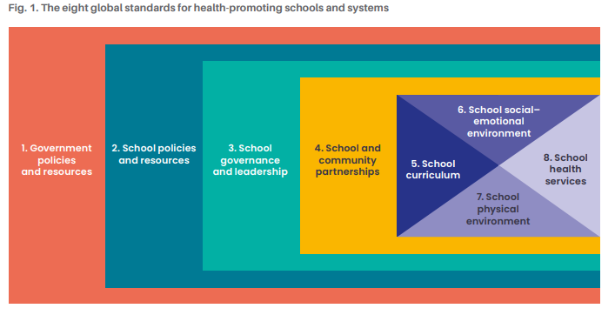
Using the Health Promoting Schools Framework global standards (particularly standards 4-8), our school aims to embed the Act Belong Commit® message into our whole school community, however, the focus of this policy is school staff.

Our school is committed to fostering a mentally healthy workplace by providing resources, support systems, and initiatives that promote staff wellbeing. We aim to create an environment where mental health is valued, stigma is reduced, and staff feel safe to seek help.
This policy incorporates Act Belong Commit® principles by encouraging staff to:

Policy Objectives

Examples provided below in red.

- ‘Increase and maintain awareness and understanding of staff that they can and should Act Belong Commit® to keep mentally healthy.’
- ‘Increase and reinforce participation in mentally healthy activities amongst school staff.’
- ‘Reduce stigma around mental illness and increase openness to discuss mental health and seek relevant support for mental health problems within and outside the school community.’
- Promote awareness and understanding of mental health among staff.
- Promote awareness and understanding of mental health among staff.
- Ensure all staff are and feel accepted and valued as individuals and professionals.
- Ensure effective health and wellbeing communication protocols are in place.
- Ensure the workplace culture promotes connectedness, is inclusive and provide diverse support networks.
- Support staff in achieving a healthy work-life balance.

Strategies

Examples provided below in red.

To achieve these objectives, the school will implement the following strategies:

Professional Support

- Provide access to Employee Assistance Programs (EAP) for confidential counselling.
- Offer professional development on mental health literacy and problem-solving.
- Offer on-site mental health check-ins or wellbeing consultations.
- Develop clear referral pathways to external mental health services.

Workload and Flexibility

- Promote flexible work arrangements where possible to support work-life balance (for example, remote work, adjusted hours) in line with school requirements.
- Regularly review workload distribution to prevent burnout.
- Encourage protected time for planning and breaks during the day.

Wellbeing Culture

- Establish wellbeing champions or a staff wellbeing committee within the school.
- Celebrate staff achievements and milestones to foster belonging.
- Promote peer support networks and mentoring programs.

Training and Development

- Provide mental health literacy training for all staff.
- Offer problem-solving and stress management workshops.
- Include wellbeing topics in professional learning plans.

Physical and Social Environment

- Create quiet spaces for relaxation or mindfulness.
- Organise social activities (morning teas, team building events).
- Encourage physical activity programs (walking groups, yoga sessions).

Communication and Feedback

- Conduct annual staff wellbeing surveys to identify needs.
- Share regular wellbeing updates via newsletters or staff meetings.
- Provide anonymous feedback channels for staff concerns.

Recognition and Incentives

- Introduce wellbeing awards or recognition programs.
- Offer small incentives for participation in wellbeing initiatives.

Confidentiality

All information related to staff mental health will be treated with strict confidentiality. Personal information will only be shared with consent or where legally required.

Responsibilities

- School Leadership: Ensure implementation and resourcing of this policy.
- Line Managers: Support staff wellbeing and facilitate access to resources.
- Staff Members: Engage with wellbeing initiatives and seek support when needed.

Review

This policy will be reviewed by [name of staff member or team or committee] at the end of every [semester/year] to identify achievements and what we can improve on, plan for the following [chosen time period] and allow staff to provide further feedback.

Date: | Signed:

