Mental Health and Wellbeing Policy Template

To successfully embed a health promotion message within your school, it is vital to include it at policy level. This enables your school to develop a clear plan of what you want to do and why. The policy should be guided by your school’s core values. This helps to ensure consistency and accountability and helps guide decision makers.

To become a Mentally Healthy School and promote mental health and wellbeing throughout the whole school community it must be reflected in your school’s Health Policy. This can be done in two ways:

- create a new Mental Health Policy with the support of the Mentally Healthy WA team; or
- incorporate new mental health specific objectives into a pre-existing Health Policy that encompass mental health and wellbeing.

When writing a policy, it is important to consider what policies already exist and what your school needs. The Health and Wellbeing committee (or a dedicated group of staff at your school that addresses this area) can work together to develop a simple policy encompassing mental health and Act Belong Commit.

This policy should be customised to suit your school’s needs, circulated to all staff and other relevant bodies (School Board, P&C, Student Council etc.) for feedback and reviewed annually. The policy will then function as a guide for the development of your Mentally Healthy Action Plan – the action plan will be practical strategies to achieve your policy’s objectives.

The following resource is a template policy to add mental health and wellbeing as an overall strategy throughout the whole school to further assist the implementation of Act Belong Commit. Use the Mental Health Policy Template or you can include some of the example objectives in your already existing Health Policy. If you require further assistance with this process, please do not hesitate to call the Schools Program Coordinator on (08) 9266 1873.

Mental Health and Wellbeing Policy Template

School Name:
Created By:
Date Created:
Date Reviewed:
Next Review:

Related Department of Education Policies [Remove if unnecessary for your school]

This policy supports the following Department of Education Policies:
Duty of Care for Public School Students Policy
Equal Opportunity Discrimination and Harassment Policy
School Improvement and Accountability in Public Schools Policy
Student Behaviour in Public Schools Policy
Student Health in Public Schools Policy
Students at Educational Risk in Public Schools Policy

Related [School Name] Policies

Please provide list / links to related internal school policies.

Rationale

This is a sample rationale, consider the context of your school and tailor it for your school’s particular needs and priority areas.

This policy will outline how we intend to embed Act Belong Commit® into our school to promote the mental health of our whole school community.

We aim to provide a safe, stimulating, and fun place to learn, work and play.

Promoting good mental health and encouraging young people to take proactive steps to protect their mental health and wellbeing are vital to mental, emotional, and physical health, and overall happiness. Young people who are mentally healthy and active, have good positive friendships and add meaning and purpose to their life, are more likely to have higher self-esteem, resiliency and confidence and achieve better academically, socially, and emotionally.

Enhancing wellbeing requires the promotion of positive mental health and wellbeing. Given many young people begin to experience mental health challenges during their schooling years, interventions to enhance protective factors are vital. School communities are an ideal setting for mental health promotion with the opportunity to reach students, staff, and parents. We aim to provide inclusive mental health promotion strategies to promote mental health and wellbeing and to equip students with help seeking skills, whilst ensuring our school staff are equipped to support and refer them to relevant services when appropriate.

Policy Statement
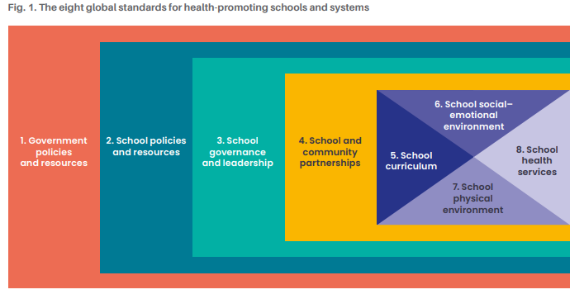
Using the Health Promoting Schools Framework global standards (particularly standards 4-8), our school aims to embed the Act Belong Commit® message into our whole school community to:

Policy Aims

Examples provided below in red.

- ‘Increase and maintain awareness and understanding of students, staff and parents that they can and should Act Belong Commit® to keep mentally healthy.’
- ‘Increase and reinforce participation in mentally healthy activities amongst students, school staff and parents.’
- ‘Reduce stigma around mental illness and increase openness to discuss mental health and seek relevant support for mental health problems within and outside the school community.’

Policy Objectives

Examples provided below in red.

We intend to develop strategies that will embed the following within our whole school community:

School and Community Partnerships

- ‘To actively engage the local community in promoting a mentally healthy school and community for students and their families.’
- ‘To participate in initiatives from other organisations, such as R U Ok Day and Mental Health Week.’
- ‘To work with local organisations to develop referral processes for all students, staff, and families.’

School Curriculum

- ‘To increase student knowledge and awareness of Act Belong Commit® and how to be mentally healthy.’
- ‘To provide opportunities for students to be mentally, physically, socially and spiritually active to help build their resilience, self-esteem and social and emotional skills.’
- ‘To support school staff to develop skills to enhance mental health and wellbeing content across all learning areas.’
- ‘To actively develop classroom curricula that promotes mental wellbeing across the subjects.’

School Social-emotional Environment

- ‘To increase school community (student, staff, parent) knowledge and awareness of Act Belong Commit® and how to be mentally healthy.’
- ‘To provide opportunities for students to connect with likeminded students, such as via clubs, groups and sporting clubs.’
- ‘To foster a supportive, inclusive school community that celebrates diversity.’
- ‘To provide education and support for families to become actively involved in their children(s) mental wellbeing.’

School Physical Environment

- ‘To establish a visible presence throughout the school as a Mentally Healthy School (physical and digital environment)’
- ‘To provide safe spaces for students to take time out (e.g., calm corner, sensory corner).’
- ‘To provide appropriate spaces for student groups to meet that support their objectives and activities.’

School Health Services

- ‘Increase student understanding of the school health services available to them.’
- ‘Support school health service staff to ensure they have the capacity and skills to support and refer students and other staff.’
- ‘Engage in meaningful professional learning related to mental health and wellbeing that ensures staff are able to respond to and support students effectively.’
Review

This policy will be reviewed by [name of staff member or team or committee] at the end of every [semester/year] to identify achievements and what we can improve on, plan for the following [chosen time period] and allow parents and staff to provide further feedback.

Date: | Signed:

