To successfully embed a health promotion message within your school, it is vital to include it at policy level. This enables your school to develop a clear plan of what you want to get done and why. The policy should be guided by your school’s core values. This helps to ensure consistency and accountability and helps guide decision makers.
Mental Health & Wellbeing Policy Template

To become a Mentally Healthy School and promote mental health and wellbeing throughout the whole school community it must be reflected in your school’s Health Policy. This can be done in two ways:

- create a new Mental Health Policy with the support of the Mentally Healthy WA team,
- incorporate new mental health specific objectives into a pre-existing Health Policy that encompass mental health and wellbeing.

When writing a policy, it is important to consider what policies already exist and what your school needs. The Health and Wellbeing committee (or a dedicated group of staff at your school that addresses this area) can work together to develop a simple policy encompassing mental health and Act Belong Commit.

This policy should be customised to suit your school’s needs, circulated to all staff and other relevant bodies (School Board, P&C, Student Council etc.) for feedback and reviewed annually at least. The policy will then act as a guide for the development of your Mentally Healthy Action Plan – the action plan will be practical strategies to achieve your policy’s objectives.

The following resource is a template policy to add mental health and wellbeing as an overall strategy throughout the whole school to further assist the implementation of Act Belong Commit. Use the Mental Health Policy Template or you can include some of the example objectives in your already existing Health Policy. If you require further assistance with this process please do not hesitate to call the Schools Program Coordinator on (08) 9266 1873.

Mental Health & Wellbeing Policy Template

School name:
Created by:
Date created:
Date reviewed:
Next review:

Rationale

This is a sample rationale, consider the context of your school and tailor it for your school’s particular needs and priority areas.

This policy will outline how we intend to embed Act Belong Commit into our school to promote the mental health of our whole school community.

We aim to provide a safe, stimulating and fun place to learn, work and play.

Promoting good mental health and encouraging young people to take proactive steps to protect their mental health and wellbeing are vital to health and happiness. Young people are more likely to have higher self-esteem, resiliency and confidence and achieve better academically if they are active, have good positive friendships and add meaning and purpose to their life.

The onset of mental illness is most likely between the ages of 12 and 17 (McGorry et al. 2007) therefore it is crucial to develop and deliver programs for young people that build their resilience and increase their coping capacity. Schools provide a near universal setting for mental health promotion since young people spend almost half their waking lives at school. We aim to equip students with the ability and skills to recognise and seek support when they need it and for our school staff to be equipped to support them and refer to relevant services when appropriate.

Policy Statement

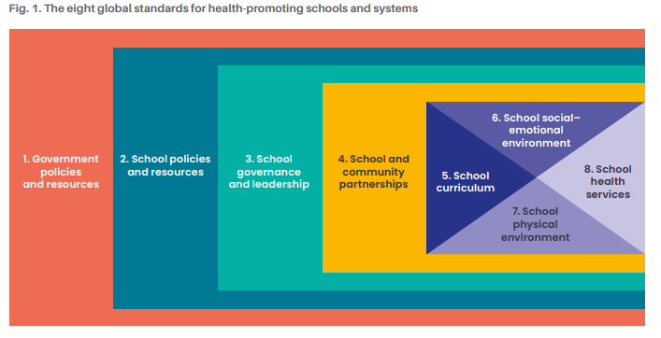

Using the Health Promoting Schools Framework global standards (particularly standards 4-8), develop school aims to embed the Act Belong Commit message into our whole school community to:

Insert overall policy aims here:
Examples provided below in red

- ‘Increase and maintain the individual awareness and understanding of students, staff and parents that they can and should do things to keep mentally healthy.’

- ‘Increase and reinforce participation in mentally healthy activities amongst students, (school staff and parents).’

- ‘Reduce stigma around mental illness and increase openness to discuss mental health and seek relevant support for mental health problems within and outside the school community.’

Policy Objectives
Examples provided below in red

We intend to develop strategies that will embed the following within our whole school community:

School and community partnerships:

- ‘To actively engage the local community in promoting a mentally healthy school and community for students and their families.’
- ‘To participate in initiatives from other organisations, such as R U Ok Day and Mental Health Week.’

School curriculum:

- ‘To increase student knowledge and awareness of Act Belong Commit and how to be mentally healthy.’
- ‘To provide opportunities for students to be mentally, physically, socially and spiritually active to help build their resilience and self-esteem.’

School social-emotional environment:

- ‘To increase school community (student, staff, parent) knowledge awareness of Act Belong Commit and how to be mentally healthy.’
- ‘To provide opportunities for students to connect with likeminded students, such as clubs, groups and sporting clubs.’

School physical environment:

- ‘To establish a visible presence throughout the school as a Mentally Healthy School (physical and electronic environment)’
- ‘To provide safe spaces for students to take time out (e.g., calm corner, sensory corner).’

School health services:

- ‘Increase student understanding of the school health services available to them.’

Review

This policy will be reviewed by [name of staff member or team] at the end of every [term/semester/ year] to identify achievements and what we can improve on, plan for the following [chosen time period] and allow parents and staff to provide further feedback.

Date: Signed:

